Flex box:
In CSS, display: flex; is a value of the display property that enables the flexible layout model for arranging the elements in a container. When you can apply the display: flex; to the container element, it can become the flex container and its direct children become the flex items.

Mainly remember 2 things
1.parent has flex container
2.childrens has flex items
We can maintain all the childrens in the one parent and we can apply properties to parent
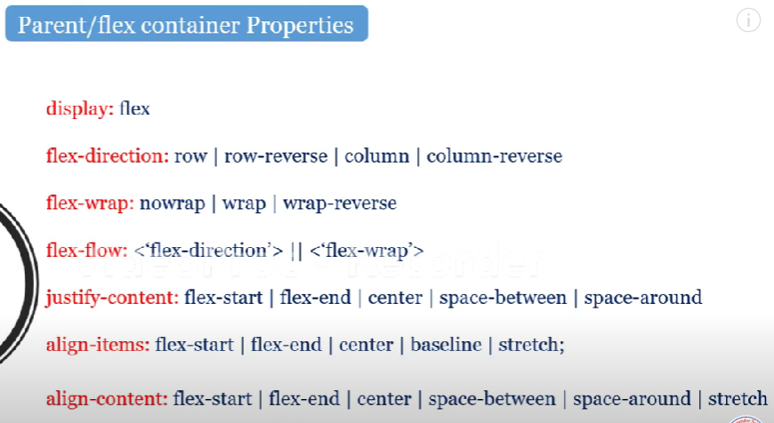
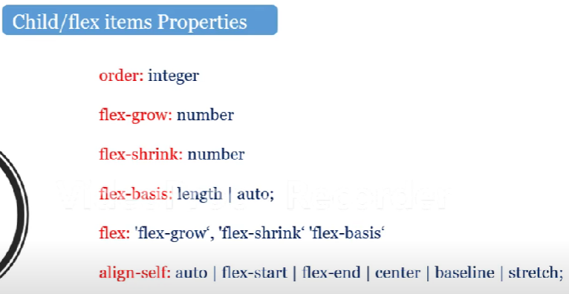
Flex is used to arrange the child elements in the line of row or column
When we apply the display: flex to parent by default the child elements will arrange in the single line and side by side

Main axis and cross axis changes based on the flex direction
If flex direction row - main axis -x and cross axis -y
Flex direction column - main axis - y and cross axis -x
justify content will decide the child elements /items are how to arranged in the main axis
Align content will decide the child items are how to arranged in the cross axis

Child items:
Based on the order value lesser order element will come first and large order element will come last
By default flex-grow is 0
After the properties applied the remaining space distributed based on the flex-growth as like percentage if we apply for 2 items that 2 items will share the remaining space based on the flex-growth value
Iw we adjust parent width 700 and 8 child items with 150 width each and we are not using flex wrap so all the child items will come in the single row and within the parent width items will exist by adjusting items width respect to parent width
Flex-shrink is the properties to decrease the width of items based on the given value
If we give 2 value then it will decreased by 2 times of the normal decreasing
Align self is applicable only for the child item where the place to settle and it will applicable for only the cross axis

GRID:

